Documentation for Localization/internationalization of widget :-

1. Need to append i18n filter to all the html tags for translation of our widget content once we have developed widget template

For Eg :- **<div class=”container”>**

**<h3 i8n>Insurance</h3>**

**</div>**

1. The translation files can be extracted from the constituent widgets.

We have to run the command in the project root: -

npm run ng -- xi18n

This will create a translation source in **apps/<application>/src/messages.xlf** . This file is a standard files used by translators that contains information about all of the text that was internationalized in all of the widgets in the application.

1. Copy the messages.xlf to apps/<application>/src/locale/messages.en-US.xlf where "en-US" is the locale identifier of the target locale.
2. Make the following changes in the index.hbs file. (Remove the old entries and paste the below one’s).

**<script type="text/javascript" src="$(contextRoot)/static/items/bb-core-app-container-ang/dist/{{locale}}/inline.bundle.js"></script>**

**<script type="text/javascript" src="$(contextRoot)/static/items/bb-core-app-container-ang/dist/{{locale}}/polyfills.bundle.js"></script>**

**<script type="text/javascript" src="$(contextRoot)/static/items/bb-core-app-container-ang/dist/{{locale}}/main.bundle.js"></script>**

**<link type="text/css" rel="stylesheet" href="$(contextRoot)/static/items/bb-core-app-container-ang/dist/{{locale}}/styles.bundle.css"/>**

(Replace **bb-core-app-container-ang** with your app specific name).

1. Run **npm run package:apps** in your project Root.
2. Import the package created in the above step by giving the following command.

**bb-import package dist/provisioning-packages/my-example-app.zip --portal-port=8080 --portal-host=localhost --portal-username admin --portal-password admin --portal-context gateway/api --portal-auth-path gateway/api/auth/login --portal-version 6**

Note : - Change the zip name according to app specifications.

1. Activate the Set Locale Widget from the Enterprise Catalog in your Portal. After activating the locale widget and setting the default and supported locales in the portal settings we can see the widget in our portal like below.

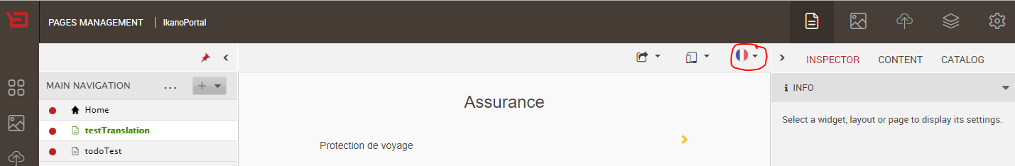

1. Go to Portal settings and give the preferences for the default and the supported locales.

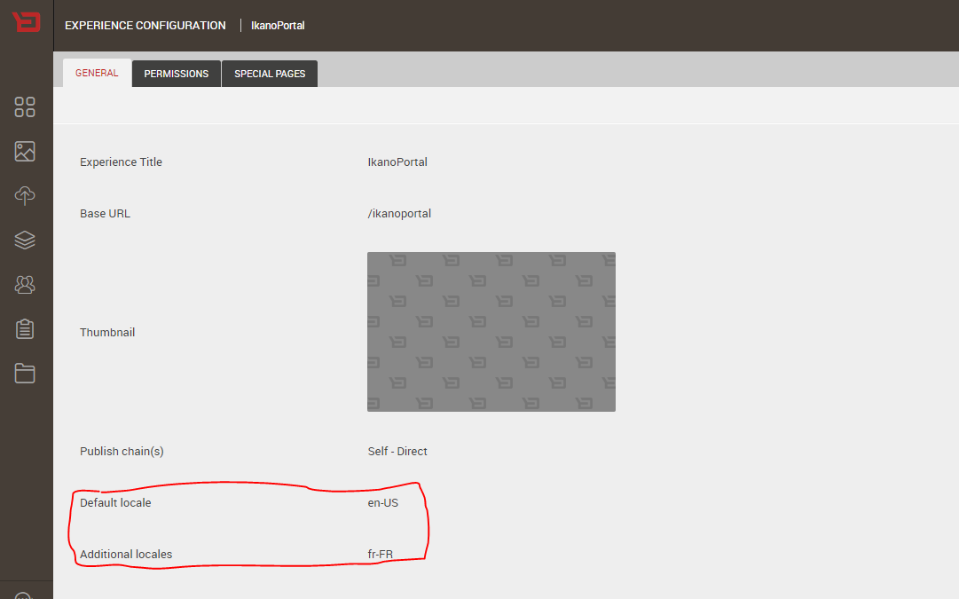

1. After selecting the particular locale the page is automatically refreshed to show the corresponding translations

**English en-US Translations :-**

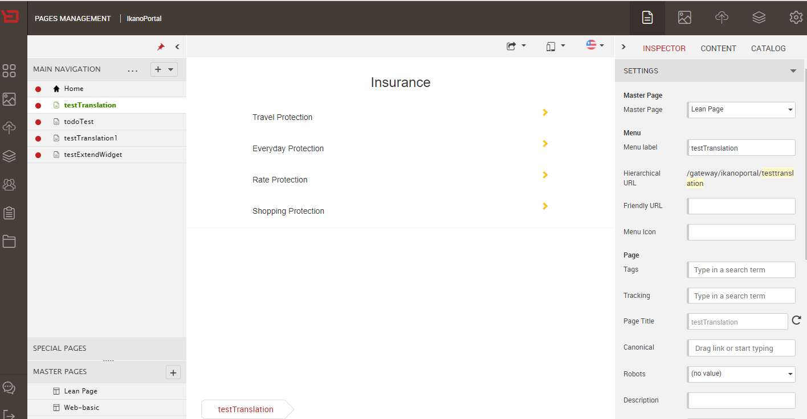

**French fr-FR Translations :-**

